How does a civilisation leave its mark?
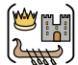
Summer Term
April - July 2025
Home learning
We want to encourage our families to be partners with us in their children’s learning; therefore, we have created some tasks which link to our current Enquiry question, that you may like to complete with your children at home. We would like all children to choose at least one activity to complete this half- term and to have brought this into school to share by Wednesday 9th July 2025.
All learning completed at home will be recognised in assemblies and celebrated within the classroom and shared school environment.

Miss Newson and Mr Leivers Dunn
1.  Read one of the books on our recommended read list and write a book review.  (Recommended read list on the back) | 2.  Research the famous Maya ball game and prepare to teach others how to play this | 3.  Prepare a 5 minute mini lesson to teach the class about Mayan Gods and Godesses.  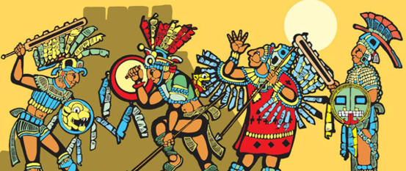
4.  Watch https://www.bbc.co.uk/bitesize/  topics/zq6svcw/articles/zkm496f  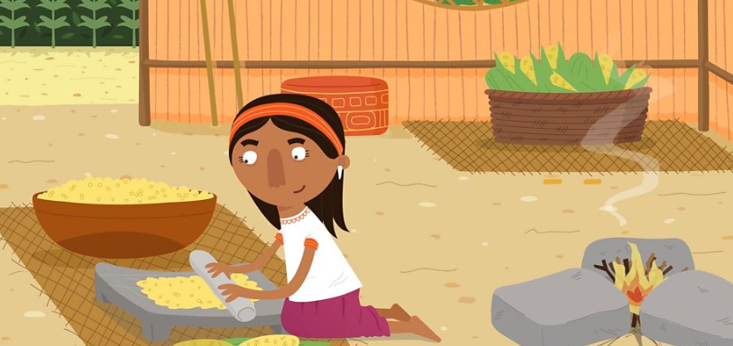  Draw a detailed diagram or make a model of the home of a Maya. How do these compare to that of an Anglo- Saxon? | 5.  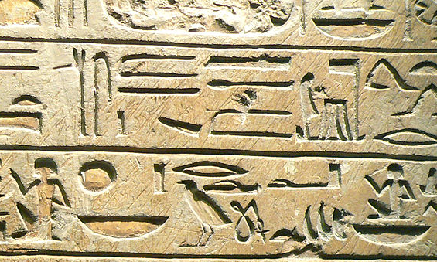  The Maya used logograms and syllabograms to communicate. Have a go at writing with these glyphs. We will put them on display. | 6.  Research the foods of the ancient Maya and write a recipe for a dish – you could even make it for your family and send in photos!  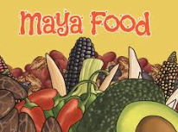
7.    Create a head-dress for an Ancient Mayan Queen or King, using recycled materials . | 8.  Did you know…  Mayan temples were built on top of flat-topped pyramids?  Design and draw or make a model of a Mayan pyramid.  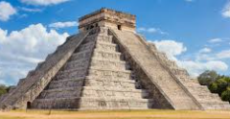 | 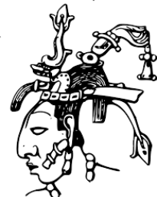  9.  Explore the life of K'inich Janaab Pakal, the longest reigning Maya king in history.  Write a story or biography about him.

Recommended Reads for this Enquiry:


